# Solaqua Design

**Focus**:

contact

awareness

**marketing**:

great products

customization

**Target** **market**:

well off

30-40

expand to car owners, camping and travel

**Uniqueness**:

Vehicle charging stations

Manufactured in-house

Made to measure

**Site** **components**:

HTML5\CSS

Responsive

Newsletter\Email-signup

Multicolumn layout

Image gallery

RSS feed\General solar info

Animations or some fancy things if possible

**Style** **guide**:

Bright(white?) green, and blue if possible. No specific colours.

A sun shining somewhere if possible, or something similar

**Logo**

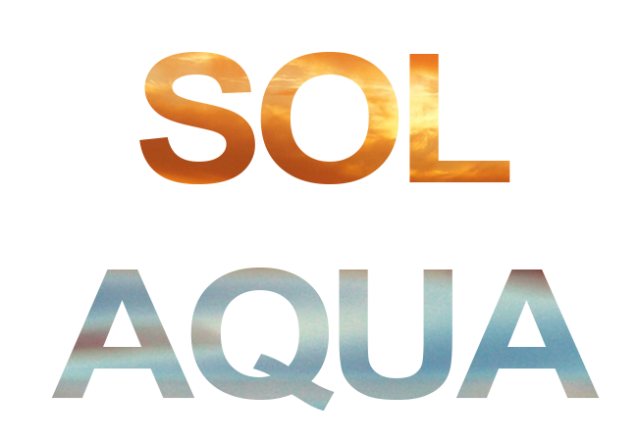

**Fonts**

Open-sans

**Colour scheme**

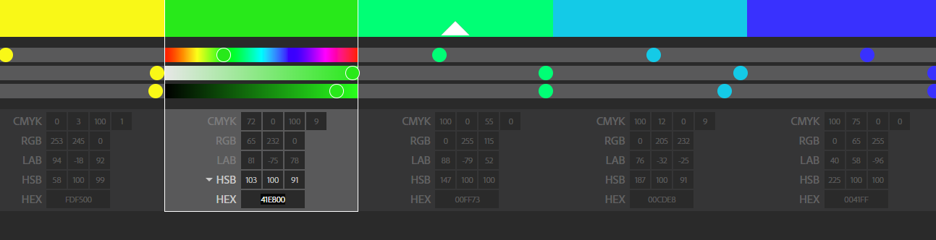

**Rgb(252, 254,0) Rgb(65, 232,0) Rgb(0, 255,115) Rgb(0, 254,232), rgb(0,64,255)**

Primary secondary Secondary Primary

